Experiment 6: Image Erosion
Aim: To read an image in Python and perform erosion using the cv2.erode() function.
Procedure:
- Read the input image.
- Convert it into grayscale.
- Create a kernel for erosion.
- Apply the erosion operation.
- Display the original and eroded images.
Program:
import cv2
import numpy as np
img = cv2.imread(r"D:\Amrita\Pictures\Screenshots\Screenshot 2026-09-30 143819.png")
kernel = np.ones((5, 5), np.uint8)
eroded = cv2.erode(img, kernel, iterations=1)
cv2.imshow("Original Image", img)
cv2.imshow("Eroded Image", eroded)
cv2.waitKey(0)
cv2.destroyAllWindows()
Input:

Output:
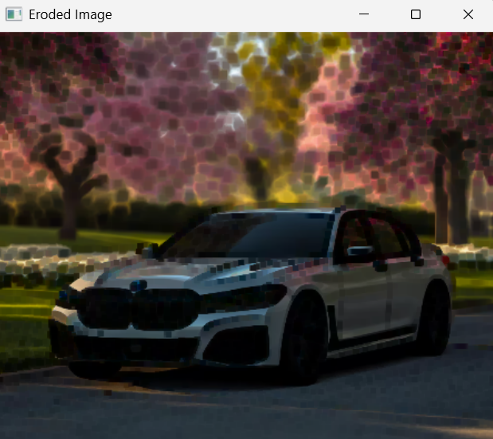
Result:
The erosion operation was successfully performed, reducing the bright foreground regions in the image.

